**Sustainable Smart City Assistant Using IBM Granite LLM**

*A Project Report*

*submitted in partial fulfillment of the requirements*

of

Generative AI with IBM Cloud

Internship

**with  
 SMARTBRIDGE** in collaboration **with APSCHE**

by

**Parise Viswa Nandini**

**Team ID:** LTVIP2025TMID34559

viswanandini3010@gmail.com

**Institution:** DMSSVH College of Engineering

# **Contents**

1. Introduction  
   1.1 Project Overview  
   1.2 Purpose
2. Ideation Phase  
   2.1 Problem Statement  
   2.2 Empathy Map Canvas  
   2.3 Brainstorming
3. Requirement Analysis  
   3.1 Customer Journey Map  
   3.2 Solution Requirement  
   3.3 Technology Stack
4. Project Design  
   4.1 Problem Solution Fit  
   4.2 Proposed Solution  
   4.3 Solution Architecture
5. Project Planning & Scheduling
6. Functional and Performance Testing
7. Results
8. Advantages & Disadvantages
9. Conclusion
10. Future Scope
11. Appendix

## 1. Introduction

### 1.1 Project Overview

The Sustainable Smart City Assistant is an innovative web application designed to empower urban planners, environmental scientists, and local government officials with advanced, data-driven tools for sustainable city management. It leverages cutting-edge AI via IBM Granite LLM, combining KPI analysis, time-series forecasting, anomaly detection, and AI chat assistance through a seamless Streamlit-FastAPI framework.

### 1.2 Purpose

To streamline sustainability efforts by enabling real-time KPI analysis, prediction, and eco-guided decision-making, enhancing efficiency and resilience in urban planning.

## 2. Ideation Phase

### 2.1 Problem Statement

Urban sustainability is challenged by fragmented systems, poor data usability, and lack of AI integration. This tool bridges the gap between data analytics and decision-making.

### 2.2 Empathy Map Canvas

**Stakeholders:** Urban Planners, Scientists, Officials  
**Say:** “We need fast, insightful analysis.”  
**Think:** “Smart tools should simplify decision-making.”  
**Do:** Upload data, use chat assistant, generate reports.  
**Feel:** Confused by complex data, desire clarity.

### 2.3 Brainstorming

* KPI uploads in CSV
* Time-series forecasts
* Chat assistant for queries
* AI news summarization (SerpAPI)
* PDF report generation with eco-friendly tips

## 3. Requirement Analysis

### 3.1 Customer Journey Map

**Awareness:** Discovered via GitHub/events  
**Engagement:** Uploads data, interacts with UI  
**Decision:** Uses reports to guide policy  
**Retention:** Regular insights, updates

### 3.2 Solution Requirement

**Functional:**  
- CSV upload, chatbot, forecasting, anomaly detection  
- PDF export, AI summaries

**Non-Functional:**  
- FastAPI backend, <2s responses, Streamlit UI

**Constraints:**  
- No authentication, CSV file storage

### 3.3 Technology Stack

**Frontend:** Streamlit, matplotlib, seaborn  
**Backend:** FastAPI, Python 3.11, statsmodels, SerpAPI, IBM Granite LLM  
**Storage:** CSV, optional SQLite/MongoDB  
**APIs:** Watsonx, SerpAPI, optional Pinecone, Google Maps

## 4. Project Design

### 4.1 Problem Solution Fit

It provides a one-stop, AI-enabled interface to guide eco-conscious city development through accurate data insights.

### 4.2 Proposed Solution

* Upload city KPI data
* Forecast trends and detect anomalies
* Chatbot interaction with IBM Granite
* Generate PDF reports with sustainability recommendations

### 4.3 Solution Architecture

See the architecture diagram 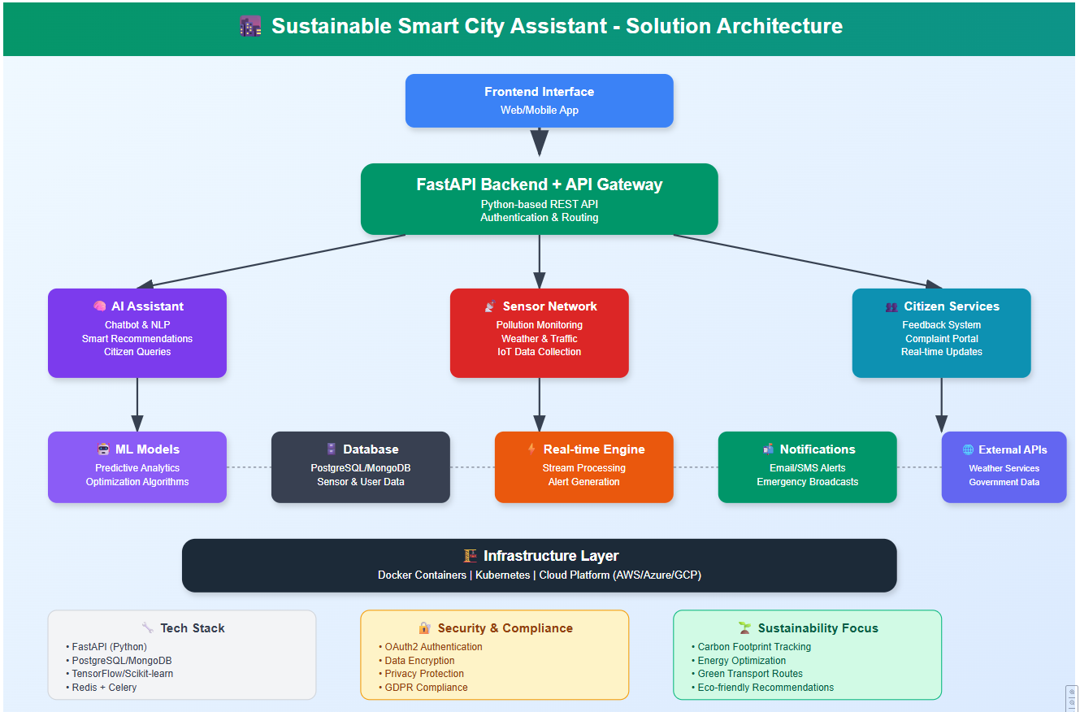

## 5. Project Planning & Scheduling

### 5.1 Project Planning

**Phase 1:** Chat assistant integration   
**Phase 2:** CSV upload   
**Phase 3:** Forecasting & anomaly logic   
**Phase 4:** Frontend UI with Streamlit   
**Phase 5:** Pinecone integration   
**Phase 6:** Voice & report modules

## 6. Functional and Performance Testing

* Forecasting & anomaly detection validated with sample data
* Chatbot tested for urban queries
* File uploads and dashboards responsive  
  **Performance Benchmarks:**
* Chat API: <500ms
* Forecast: <2s
* News Summary: <3s

## 7. Results

### 

### 7.1 Output Screenshots

**Figure 1:** Chat Assistant

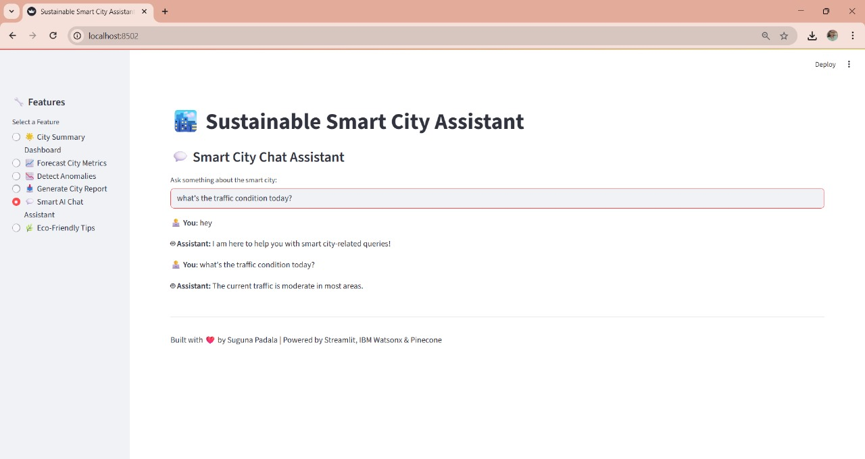

**Figure 2:** Report Generation

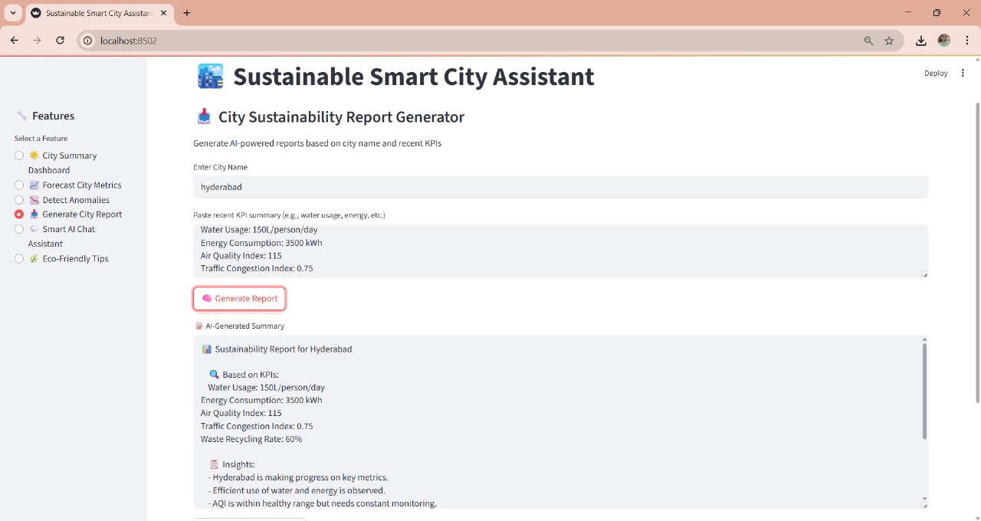

**Figure 3:** CSV Upload & Forecast

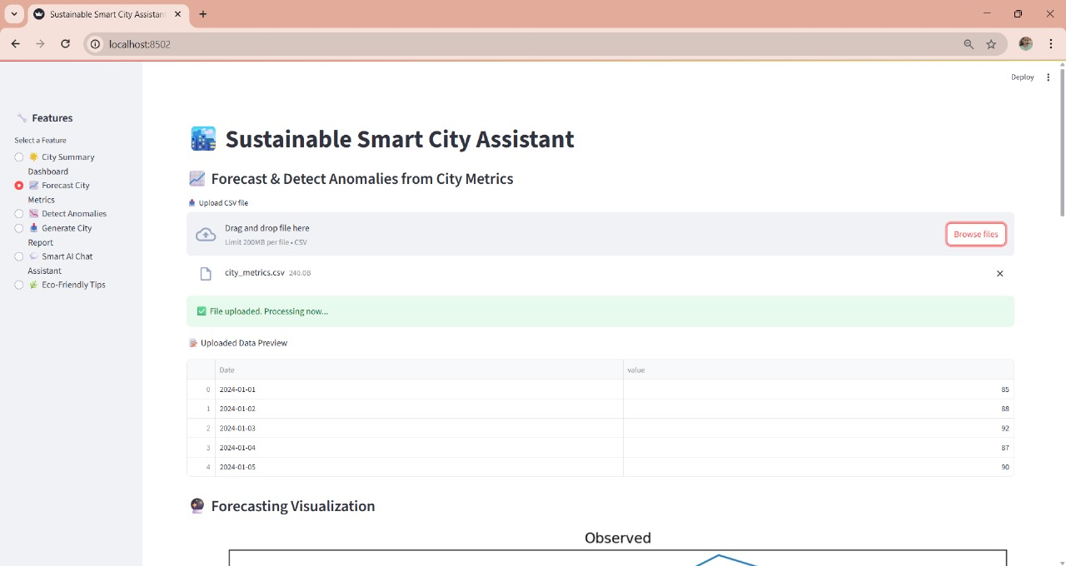

**Figure 4:** Anomaly Detection Graph

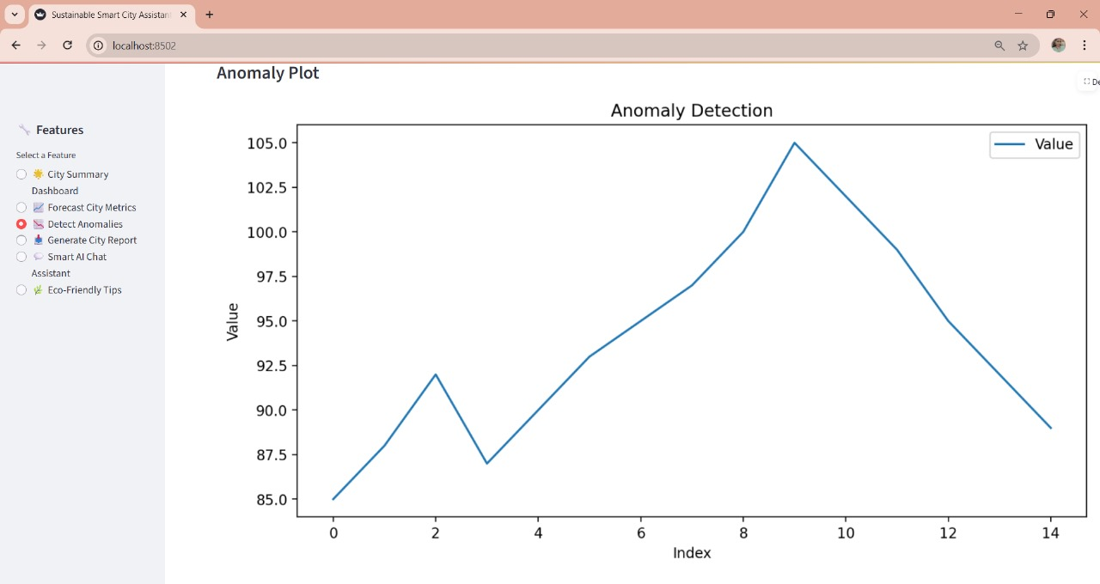

**Figure 5:** KPI Dashboard

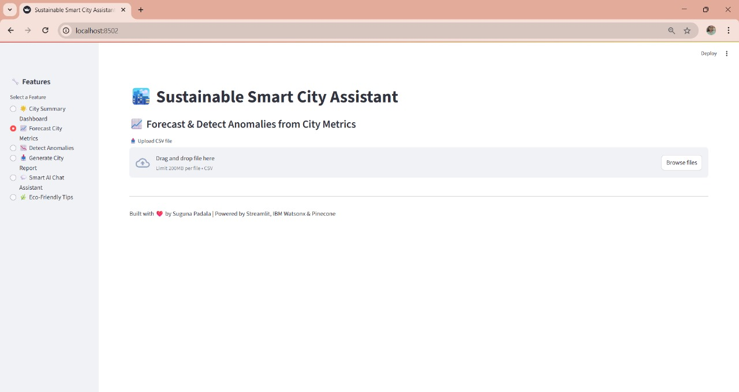

### 

### 7.2 Sample Outputs

**Sample Forecast:**  
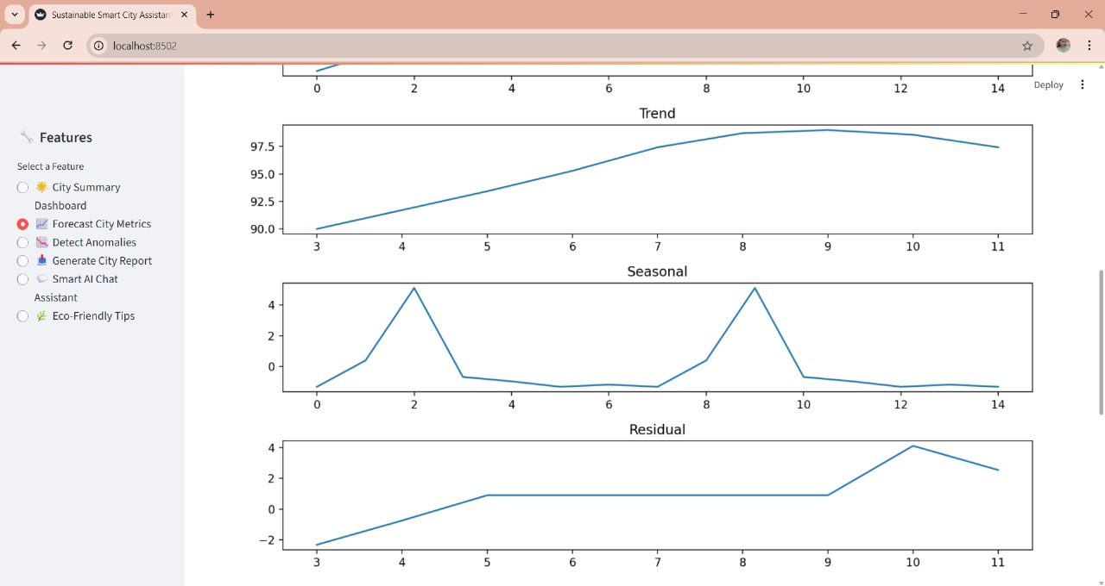

## 8. Advantages & Disadvantages

### 8.1 Advantages

* User-friendly Streamlit UI
* Modular FastAPI backend
* Real-time assistance with IBM LLM
* Extensible with future integrations

### 8.2 Disadvantages

* Relies on CSV, no DB by default
* No user auth or multi-role setup
* Voice/semantic features not fully implemented

## 9. Conclusion

The Smart City Assistant demonstrates a viable approach to sustainable city analytics using LLMs, forecasting models, and real-time tools. It meets current planning needs while offering a roadmap for scalable innovation.

## 

## 10. Future Scope

* Role-based authentication (OAuth2/JWT)
* DB storage (SQLite/MongoDB)
* Real-time IoT integration
* Map route planning APIs (Google/TomTom)
* Multilingual support & voice assistant
* Domain-specific AI news curation

## 11. Appendix

11.1 GitHub & Project Demo Link

[Project Demo Video URL](https://vimeo.com/1096858547?share=copy)

[My Github Repo](https://github.com/Sugunapadala/Sustainable-Smart-City-Assistant)